Set Up a Monthly Donation for Sai Baba Temple, Regina
Support the Sai Temple Regina by setting up a recurring monthly contribution on Zeffy. Please follow the steps below to set it up:
- Open the Zeffy donation page. Zeffy is our fundraising platform.
👉 Monthly Donation – Sai Temple Regina

- Choose your monthly amount
  - Select a suggested amount ($50, $100, $200, $500), or
  - Enter your preferred custom amount
  - Click Continue
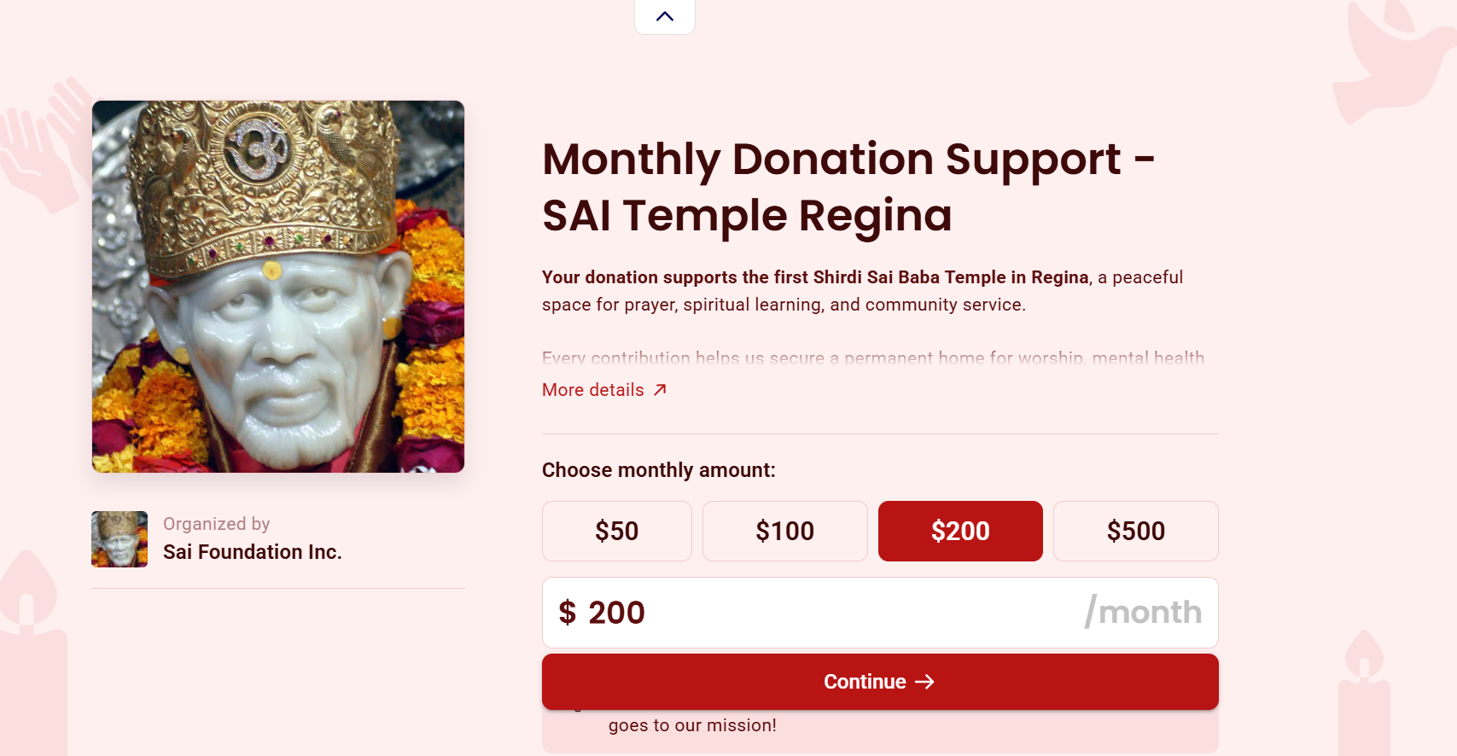

- Enter your details
  - Fill in your information (Email, Name, Province, Country, etc.)
  - In the “Help keep Zeffy free” section, select “Other”
  - Set the contribution amount to $0
(This ensures 100% of your donation goes to Sai Foundation Inc.)
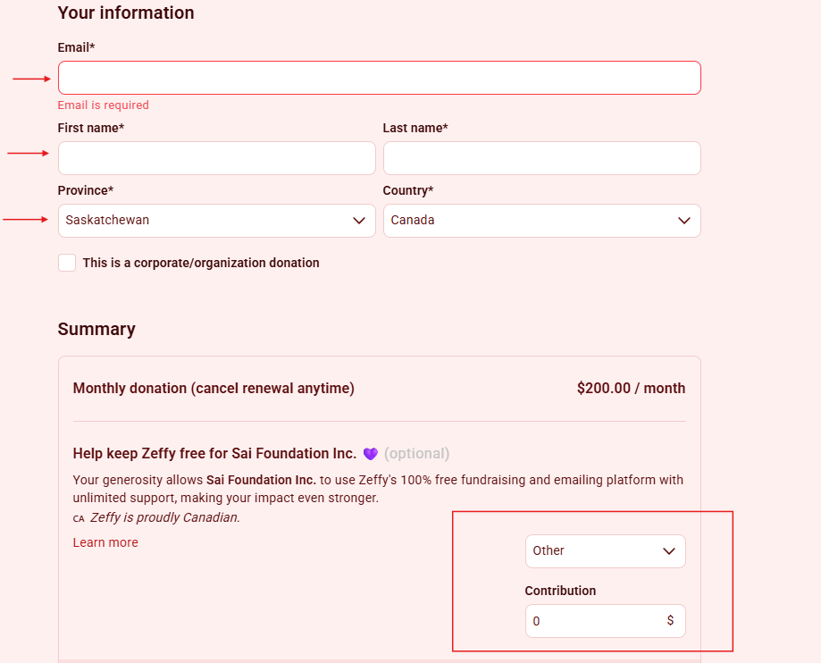
- Complete your payment
  - Choose your preferred payment method:
    - Credit Card (enter card number, expiry date, and security code), or
    - Pre-authorized debit (PAD)
  - Review the total (e.g., CAD $200/month)
  - Click Donate to activate your monthly contribution
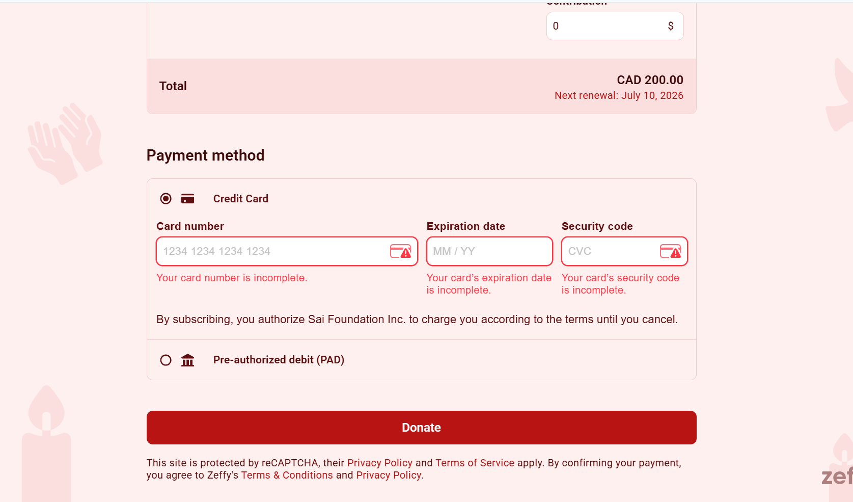
Every monthly contribution will help sustain and maintain Baba’s Temple in Regina. Thank you for your continued support. 🙏

